3 Shortcut Cheat Sheet

# Support for Emmet is Standard

Visual Studio Code has Emmet preinstalled. So, there is no need to add any extension. You can get more short cuts [here](https://devhints.io/emmet).

# Emmet Short cut for creating HTML Boiler Plate code

Shift-exclamation-Enter will give you the boiler plate code

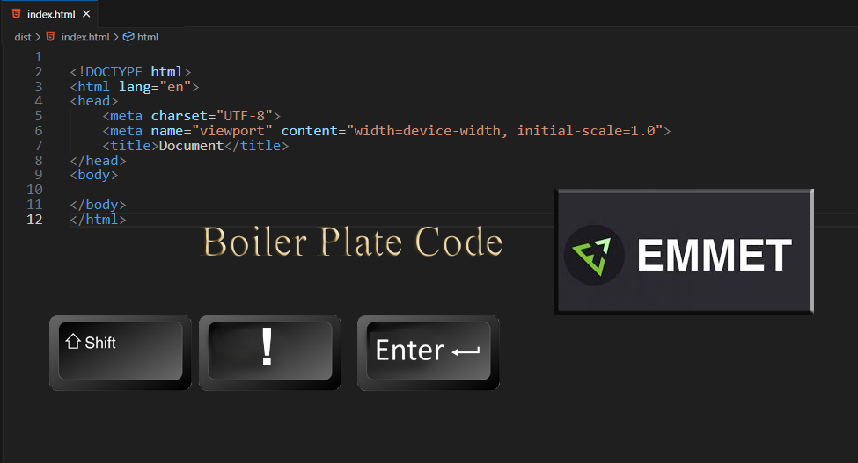

# To Add Lorem auto text filler

in your paragraph tab, write out the word **Lorem 50**, hit **enter** and this will give you 50 words in Lorem ipsum. You want to add this div, with a paragraph, and some text, so we can test our new styles.

**INDEX.html**

<body>

<div class="main">

<p>Lorem ipsum dolor, sit amet consectetur adipisicing elit. Temporibus rem voluptatum accusantium itaque atque eum rerum velit veniam, ratione architecto, officiis ab impedit ut assumenda quisquam. Ipsum autem laboriosam illum nobis facere, unde ea, aut nesciunt eius, a voluptas non iste consequatur soluta molestiae doloribus quae esse iusto? Vel, id!</p>

</div>

</body>

# To Duplicate Code

If you want to duplicate a line of code. Hover over the line you want to duplicate, and then hit alt-shift-down- arrow.

